**LAPORAN PRAKTIKUM**

**PROSES ENSKRIPSI DAN DEKSRIPSI CAESAR CIPHERTEXT UNTUK KODE ASCII MENGGUNAKAN PYTHON**



**ANGGOTA KELOMPOK :**

**1) RISKY MEISA SAPUTRA (2055201122)**

**2) RODHWATUS SA’ADAH (2055201145)**

**KRIPTOGRAFI 7.3**

**PROGRAM STUDI TEKNIK INFORMATIKA**

**FAKULTAS TEKNIK**

**UNIVERSITAS MUHAMADIYYAH BENGKULU**

**2023**

**Praktikum :** Membuat desain aplikasi python untuk menyelesaikan proses enkripsi dan dekripsi Caesar Ciphertext untuk kode ASCII.

* **DESIGN (RISKY MEISA SAPUTRA)**

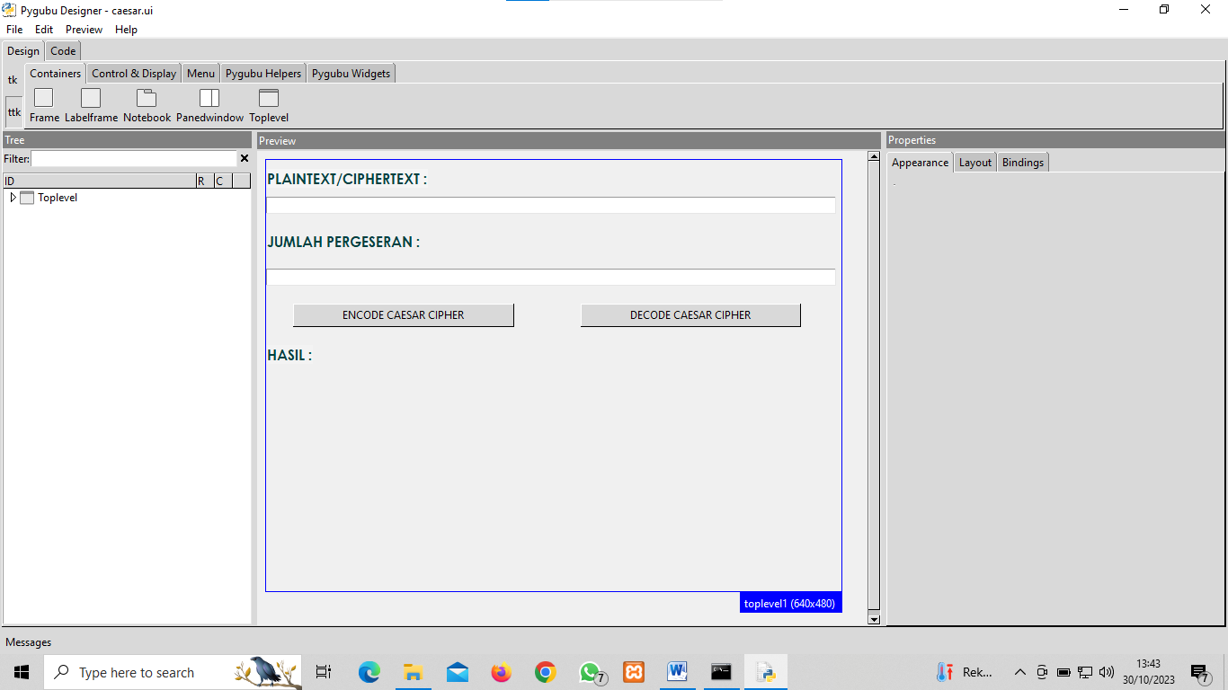

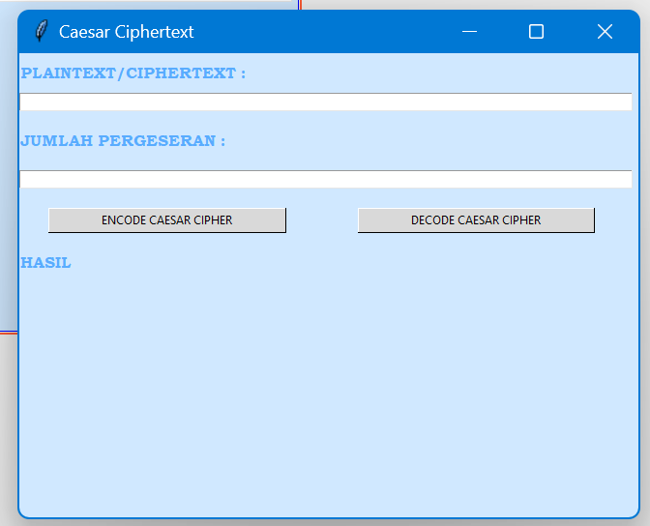

* **ENSKRIPSI DAN DESKRIPSI**

**SOURCE CODE :**

**#!/usr/bin/python3**

**import tkinter as tk**

**import tkinter.ttk as ttk**

**class CaesarApp:**

**def __init__(self, master=None):**

**# build ui**

**toplevel1 = tk.Tk() if master is None else tk.Toplevel(master)**

**toplevel1.configure(background="#d0e8ff",**

**height=200, pady=10, width=200)**

**toplevel1.geometry("640x480")**

**toplevel1.title("Caesar Ciphertext")**

**if geser == '' or geser == 0:**

**geser = 3**

**geser = int(geser)**

**def encode():**

**p = entry2.get()**

**chipertext = ''**

**for karakter in p:**

**cbaru = chr((ord(karakter)) % 256)**

**chipertext += cbaru**

**label2.configure(text='HASIL : ' + chipertext)**

**return**

**def decode():**

**p = entry2.get()**

**plaintext = ''**

**for karakter in p:**

**cbaru = chr((ord(karakter)-geser) % 256)**

**plaintext += cbaru**

**label2.configure(text='HASIL : ' + plaintext)**

**return**

**label5 = ttk.Label(toplevel1)**

**label5.configure(**

**background="#f5f5f5",**

**font="{Bookman Old Style} 12 {bold}",**

**foreground="#59acff",**

**text='PLAINTEXT/CIPHERTEXT :')**

**label5.grid(column=0, row=0, sticky="nw")**

**entry2 = ttk.Entry(toplevel1)**

**entry2.configure(width=105)**

**entry2.grid(column=0, pady=10, row=1, sticky="w")**

**label1 = ttk.Label(toplevel1)**

**label1.configure(**

**background="#f5f5f5",**

**font="{Bookman Old Style} 12 {bold}",**

**foreground="#59acff",**

**text='JUMLAH PERGESERAN :',**

**)**

**label1.grid(column=0, pady=10, row=2, sticky="w")**

**button1 = ttk.Button(toplevel1)**

**button1.configure(**

**takefocus=False, text='ENCODE CAESAR CIPHER', command=encode)**

**button1.grid(column=0, ipadx=50, padx=30, pady=10, row=5, sticky="w")**

**button2 = ttk.Button(toplevel1)**

**button2.configure(text='DECODE CAESAR CIPHER', command=decode)**

**button2.grid(column=0, ipadx=50, padx=350, pady=10, row=5, sticky="w")**

**label2 = ttk.Label(toplevel1)**

**label2.configure(**

**background="#f5f5f5",**

**font="{Bookman Old Style} 12 {bold}",**

**foreground="#59acff",**

**text="HASIL :",**

**)**

**label2.grid(column=0, pady=10, row=6, sticky="w")**

**entry1 = ttk.Entry(toplevel1)**

**entry1.configure(width=105)**

**entry1.grid(column=0, pady=10, row=4, sticky="w")**

**# Main widget**

**self.mainwindow = toplevel1**

**def run(self):**

**self.mainwindow.mainloop()**

**if __name__ == "__main__":**

**app = CaesarApp()**

**app.run()**

* **ENKRIPSI (RODHWATUS SA’ADAH)**

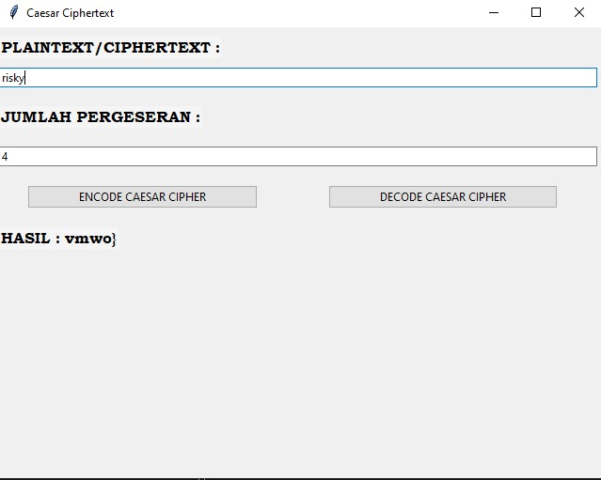

Inilah hasil enskripsi dengan jumlah pergeseran 4

* **DEKRIPSI (RODHWATUS SA’ADAH)**

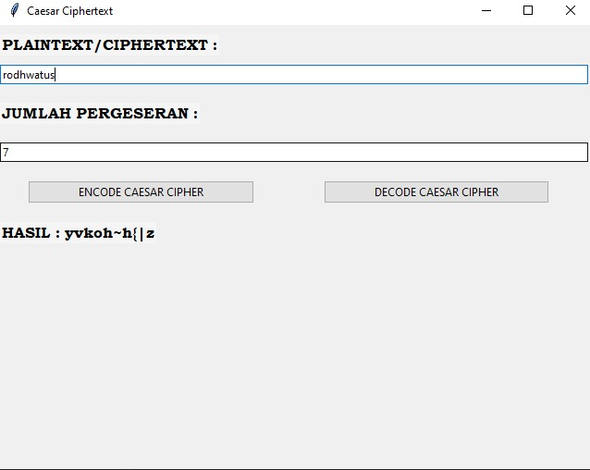

Inilah hasil denskripsi dengan jumlah pergeseran 7